# 

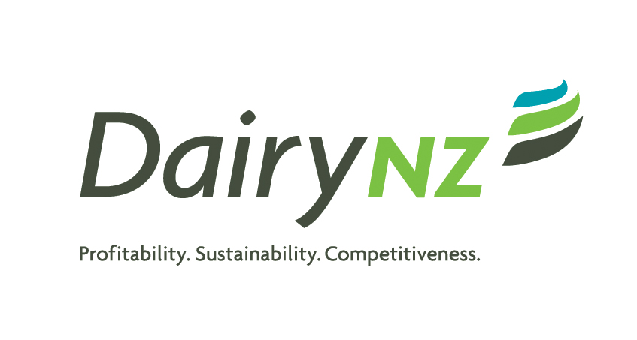



**DairyBase Data Request Form**

# (Please refer to the attached Guidelines)

[**https://www.dairynz.co.nz/business/dairybase/**](https://www.dairynz.co.nz/business/dairybase/)

|  |  |  |
| --- | --- | --- |
| 1. **Contact Details** | | |
| Name of Applicant | **:** |  |
| Project Title | **:** |  |
| Project code | **:** |  |
| Contact Person | **:** |  |
| Physical and Mailing Address | **:** |  |
| Phone Numbers | **:** |  |
| Email Address | **:** |  |

|  |
| --- |
| 1. **Project Details** |

**2.1 Aim and Purpose:**

**2.2 Benefit to the New Zealand Dairy Industry:**

**2.3 Data requested:**

**Are you requesting aggregated (average) and / or individual farm data?**

**Dairy season(s):**

**Region(s):**

**Business type:**

**Parameters/KPIs requested:**

**2.4 Method of analysis:**

**2.5 End use of data:**

|  |  |  |  |
| --- | --- | --- | --- |
| Start date | | **:** |  |
| End date | | **:** |  |
| Final report date | | **:** |  |
| Intellectual property List any intellectual property that may arise from this project and related to the use of DairyBase data.  (if applicable). | | | |
| Applicant Group / Organisation signature | | | |
| Name: | Signature: Date: | | |

**Guidelines**

The headings below relate to the headings on the DairyBase Data Request form. Please provide the requested information in a clear and succinct style. It is preferable that applications are typed but legible hand-written applications will be accepted.

1. **Contact Details**

**Name of Applicant:** The name of the individual group or organisation to whom data would be provided / contracted in the event that the application is successful

**Project title:** Maximum 75 characters

**Project code:** Time involved in extracting the data will be charged to the project code provided.

**Contact Person:** The primary contact person. This person should have sufficient knowledge about the application to answer any queries.

**Physical and Mailing Address:** Of the Contact Person

**Phone Numbers (Land-line and Mobile):** Of the Contact Person

**Email Address:** Of the Contact Person

1. **Project Details**
   1. **Aim and Purpose:** Provide a clear statement of the aim and purpose of the project.
   2. **Benefit to the New Zealand Dairy Industry**: Detail what the project is going to produce at the end, i.e. what problem is going to be solved or opportunity/advantage will be gained. Describe how this will benefit New Zealand dairy farmers.
   3. **Data Requested:** List the data or data type requested and whether it is aggregate with supporting statistics or individual farm data.
   4. **Methods of Analysis:** List the methods that will be used to analyse the data. These need to be to a standard acceptable to the industry area.
   5. **End Use of Data:** Indicate how the data/information will be presented in publications, presentations and discussions.
   6. **Start date:** The date when the data is needed.
   7. **Completion date:** The date when the project is expected to be completed.
   8. **Final report date:** The date when a final report on data use and its destruction will be provided to DairyBase.
   9. **Intellectual property:** Provide details of any intellectual property (IP) that may arise from the project that uses DairyBase data. Any IP arising from this project will be owned by DairyNZ and be managed in the best interests of farmers. Commercial IP arising from the project can be granted to the applicant as a first right of refusal to commercialise.
   10. **Applicant/Group Agent signature:** The signature of the individual authorised to approve the submission of the application or the name of the individual if emailing.

**General Information**

1. **Application:** Applications can be made at any time. Allow a minimum of four weeks for review.

Post: DairyBase, Private Bag 3221, Hamilton, New Zealand

*or* Email: info@dairybase.co.nz

1. **Application Assessment:** Once submitted, DairyBase will acknowledge receipt and decision will be communicated to applicant following review.
2. **Confidentiality:** Any advisors or referees comments solicited by DairyBase are confidential to DairyBase. Information in the application will remain confidential to the applicant, DairyBase management and advisors.
3. **Limitations on data release:**
   1. Project benefits the New Zealand Dairy Industry
   2. Only data required to meet projects aim/purpose
   3. Aggregate data sets have a minimum of 20 data points and use regions not smaller than those specified by DairyBase
   4. Individual farm data has identifiers removed and may have unique identifiers added for between year comparisons
4. **Limitations on data publication:**
   1. Minimal statistical requirements are completed and standard methods used
   2. Confidentiality of individual farm data is not compromised. An average person is unable to identify the individual farm to which the data belongs in any publicised material (published, presented and/or discussed).
5. **Evaluation:** If the application is favourably assessed the parties will then enter a negotiation phase which may include submission of more detailed information on the project and restrictions on data use.

If the application is declined, DairyBase will endeavour to provide feedback but will not enter into discussions over its decision.

1. **Contract of service:** All successful applications will be contracted before receiving the data.